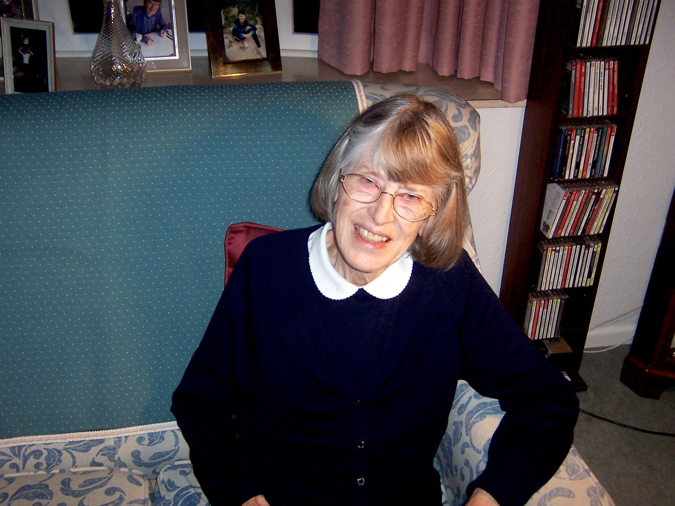
The Kite

City Road History

by

Elizabeth Leggatt
written 4.5.1982

City Road is situated in the north-east part of Cambridge, in an area known as the Kite, on account of its distinctive shape. The Kite is bounded on the north by Maids’ Causeway and Newmarket Road, on the south-east by East Road, on the south-west by Parker Street and Parkside bordering Parker’s Piece and on the north-west by Emmanuel Road and Short Street, adjoining Christ’s Pieces. City Road lies towards the centre of the Kite, running approximately south-west to north-north-east between Prospect Row and Fitzroy Street.

Recent and controversial demolition and re-development has robbed the Kite internally of part of its original character and layout. The construction of the roundabout on Newmarket Road, at its junction with East Road and the new Elizabeth Way to the north, has obliterated its north-east corner. The changes can best be seen by comparison with the pre-development maps with those of the present day, but in spite of these breaks the Kite remains recognisably similar in outline. It forms part of the Parish of St. Andrew the Less but the district has always been known as Barnwell as it formed the estate of Barnwell Priory, whose history can be traced from its foundation in 1092 until The Dissolution.

The Kite as a name does not appear to be ancient, but its shape can be easily discerned on the Enclosure Award Plan of 1811, when it was still called by the field name of Clay Angles. Alternatively know as Clapham Glee or Clay Hanger, it was part of a larger field called Bradmore, whose memory is retained in the street of that name on the south-east side of East Road.Bradmore Field extended as far as Oldham’s Common on the east and was one of the four open-fields of Barnwell, also called the East Fields of Cambridge. In 1800 Stourbridge Field lay to its north, with Middle and Ford Fields to the south, extending westwards to Coe Fen. David Loggan’s View of Cambridge from the East (1690) shows the long strips in the arable fields with sheep grazing the stubble.

The earliest reference to the East Fields occurs in 1155, when they were known as Bradmere and Meleditch, Middil, Fordhel and Estenhale (later part of Stourbridge). These field remained open until 1811, the only enclosed portions being some very small closes, mainly clustered around the cottages on the opposite side of the road from St Andrew’s Church. The largest close, of 18 acres and 26 perches, belonged to the ‘Person or Persons entitled to the estates of the late Thomas Panton,’ and consisted of Horsefair Close, a hopyard, sedge yard, forming part of the Abbey Farm next to the church. Interestingly, one of the old enclosures, no. 51, is a long way from Barnwell village, and later became the City Bus Station. It already belonged to the Corporation of Cambridge in 1811, and was called Milestone Close. It is approximately one mile from City Centre and the O.S. map still records a millstone on its north side.

LIST 1
The old enclosures, which included the village farms and cottages,
are numbered 1-51 and are listed on the Enclosure Award Map.

ENCLOSURE OF BARNWELL
The new allotments of 1811, awarded to the proprietors of the former scattered strips in the fields, are shown on the Enclose Award map and described in the schedule. Stourbridge Fair Green (Stourbridge Common), Oldham’s Common, Midsummer Common, Christ’s Pieces, Jesus Green, Butt Green and Parker’s Piece were exempt from he award.
MAP 5 LIST II
On the re-drawn enclosure map the allotments are numbered 52-142 and are listed separately as the scale is too small for all the details of ownership and acreage.

ABSTRACT OF THE TITLE OF 33 CITY ROAD
Number 33 City Road has a well preserved set of deeds dating from 1850, and an abstract of the title to the property which makes it possible to study the previous history of the site in some detail. It must be said at the outset, however, that some of the descriptions of the property transactions recited in the abstract of the Title are confusing, and that without further evidence the following attempt to interpret them is provisional.

PLAN 1a & 1B UNDERLAY JAMES BURLEIGH’S AWARD
The land on which the houses numbered 28 to 53 (on the west side of City Road) stand shared a common history from 1824 to 1848, but before and after this, ownership was divided. When the common-fields were enclosed in 1811, the part to the north-east of line AB (approximately the line of the back garden walls of Paradise and Grafton Streets projected through no. 40 City Road) was included in the 17 acres in Clay Angles which formed James Burleigh’s third allotment. This was awarded in lieu of his ‘Freehold Open Fields Lands and Rights of Common’ etc in Barnwell, St. Andrew the Great, St. Mary the Great and St. Mary the Less in Cambridge. The land on the south west of line AB formed the second allotment awarded to Olivia Palmby of 7 acres, 3 roods and 3 perches. The pre-enclose history of their title deeds is recited in the abstract of the title to no. 33 City Road which traces James Burleigh’s Cambridge and Trumpington properties back to 1734 and Olivia Palmby’s to 1747.

Olivia Palmby’s Award Ref 3.P.3 Title Deeds Ref 3.P.5.

In the indentures of the latter, dated July 26 and 27, 1747, the parties included Sir Frances Whichcote Baronet and Dame Frances his wife (with others) of the one part and Edward Palmby, maltster, of the other.

Both James Burleigh and Olivia Palmby are mentioned as proprietors on the list of old enclosures in 1811. James Burleigh owned a farmhouse and premises of 3 roods, 35 perches on the north side of Barnwell Causeway* (later Maids’ Causeway). Map 6 and Ref 5. C16 & 16 maps show it as Barnwell Causeway. This is no. 14 on the map and must have been approximately opposite the present Christ Church. Olivia Palmby owned a cottage and yard of 22 perches next to the church (St Andrew the Less) - no. 6 on the map - almost opposite. They both received more than one allotment at Enclosure - James Burleigh was awarded about 63 acres freehold and Olivia Palmby 14 acres or so.

Old Enclosures of JB. and O.P. Map 5, List I
New Allotments 1811 List II

Eight years after Enclosure, in 1819, (Ref 3, P4) the first transactions leading to the amalgamation of parts of their two allotments in Clay Angles took place. On December 21 and 22 1819, William Palmer purchased 6 acres, 2 roods, 12 perches of the 7a, 3r, 3p, formerly Olivia Palmby’s. The exact boundaries of this plot are not given but can be inferred from the subsequent transaction to be probably as shown on plan 2: there are no further references to the strip bordering Gravel Pit Road (later East Road) - an area of approximately an acre.

Plan 2 & Underlay Thomas Palmer 1820 Ref. 3. P1-2

Soon afterwards (March 30 and 31 1820) Thomas Palmer purchased 5 acres, 1 rood, 39 perches from James Burleigh for £1,239, an area stretching from the present Burleigh Street to the line AB and from Gravel Pit Road to the line of Eden Street and Fitzroy Street. These boundaries are not in any doubt, being clearly described in relation to the allotment on all sides as shown on the Enclosure Award. Four years later, Thomas Palmer bought a further 3a, 1r, 36p from William Palmer for £534.13.3d, on November 5 and 6, 1824. This purchase united the two parcels of land which eventually came to form City Road and its neighbourhood. It seems possible that William and Thomas Palmer were relatives as they were both parties to the earlier transaction for 6a, 2r, 12p of Olivia Palmby’s, of which the 3a, 1r, 36p formed a part. Its position has again been inferred by the description of the boundaries on three sides and the reference to the carriageway on the east side leading to the East Road or Gravel Pit Road. The carriageway on the east must have been Adam and Eve Row, now known as Adam and Eve Street, but referred to as Adam and Eve Row on Map 3 O.S. Cambridge Sheet XLV11.2&3. 1888, with an exist either by Dover Street or Burleigh Street. It is unfortunately that the plan referred to as being in the margin of the indenture is not reproduced in the copies as this would clean up any uncertainty on the matter of the carriageway.
Shortly after the purchase, Thomas Palmer made an agreement with Fishers, a Cambridge banker’s firm, to mortgage the newly acquired property, together with 2 acres, 2 roods, 10 perches on his adjoining land, for £600 at 5% interest PA for 1000 years unless redeemed by certain dates. (Nov 8th 1824, Mortgage, Ref 3.P.6) This area appears to have extended to the carriageway mentioned above on the south-east, by the back garden boundaries of the future Burleigh and Paradise Street houses on the north—east, by the back garden boundaries of the future City Road and Eden Street houses on the north-west and by what was to become Brandon Place on the south-west. (Plan 4 and underlay) It does not appear to have included the house sites at the extremities of City Road west side, nos. 25-27 and no. 54. Those at the north-west end would have been part of the residue of the 5a, 1r, 39p which Thomas Palmer is said to have sold off and conveyed to diverse persons by November 8, 1824. (Ref 3.P.6) This land has been set out and used as building ground and as a private road. The architectural and cartographic evidence supports the suggestion that this land formed the future Burleigh Street (south-west side), Adam and Even Row and Eden Street, with development at the same time in Prospect Row and Brandon Place on the rest of William Palmer’s land. (Ref 4)
The Royal Commission for Historical Monuments, Cambridge says that R.G. Baker’s map of Cambridge of 1830 shows Prospect Row, Adam and Eve Row and Burleigh Street enclosing the ‘Garden of Eden,’ and Brandon Place rising. The reference to the ‘Garden of Eden’ is interesting as the mortgaged area in the agreement of 1824 included the Greenhouse, Hothouse and other buildings standing on the 2a, 2r and 19p, although the plots themselves are still described as being in Clay Angles.
Thomas Palmer’s will of 1825 (Ref 3.P.7) instructed his executors to sell his freehold land in St. Andrew the Less, Cambridge, to the best advantage for his heirs. He must have died sometime between this date and 1832 as his will was proved in the consistory court at Ely on November 12, 1832. (Proved 1832 Ely C.C. Redemption of Mortgage Ref 3.P.8 & 9) The receipts for the principal and interest of the mortgage were dated 15 August 1834 and 6 May 1847 respectively, and the indenture of February 16, 1848 recites that Thomas Palmer’s widow, now remarried to Frances Gifford, had sold part of the freehold ground in Cambridge and redeemed the mortgage. It only remained to sell off the land as building plots in order to provide for the heirs. The affair was put in the hands of Charles Henry Cooper, solicitor, who carried out the transactions. (1848 Sale Plan 5 & Underlay) The following day the west side of City Road was auctioned as 24 lots of building ground by Charles Wisbey at the Horse and Groom, King Street, Cambridge at 7pm. (Ref 6) (Most of the plots were 17’ wide and from 107’ to 70’ long, those at each end being longer. Besides the building plots, there were four lots consisting of a greenhouse, dwelling house, Octagon pump House, lean-tos and cucumber frames.These had to be dismantled and carted away at the purchaser’s expense.
The bill of sale shows the plan of the plots fronting on to the new street ‘to be called City Road, Garden of Eden.’ This bill is invaluable in giving many details which are not shown on any other document, including the dimensions of the plots. The names of the occupants of the built houses at the north-west end of City Road and Eden Street are also shown, and the curious little irregularities of property boundaries which can still be traced on the O.S. 25” map of 1888. No. 33 was lot 18, being 17’ wide and 98’ long. (Map 3, Lot 17 & 18 Mr Wm. Wingell) It was bought with Lot 17 (no 34) by Mr William Wingell, for whom the abstract of the title was prepared. The houses were built in about 1850 and the deeds for no. 33 are remarkably complete from this date.
The indenture of 1848 described the land eventually sold as containing 5 acres and 3 roods or thereabouts, ‘then used as a garden and then and for many years past known by the name of the “Garden of Eden”, and also refers to the outhouses. (Ref 3.P.9 Garden of Eden Ref & and post script)
Thomas Palmer himself was described in the indentures as a gardener living in Ely. There is also a reference to your messuages which were to be sold for the heirs of Thomas Palmer. Two were in or near Prospect Row, one in or near Eden Street and the other in or near Burleigh Street. It seems that these must have been built on the land sold off by Thomas Palmer by 1824 but the reference is confusing. Neither is the meaning clear with regard to the ‘5 acres and 3 roods or thereabouts,’ as the area of land sold after the mortgage was discharged was 6 acres and 6 perches a discrepancy of 1 rood, 6 perches. Nor are we told which property was sold by Thomas Palmer’s widow in order to redeem the mortgage, and as he has sold the remainder of the 5a, 1r, 39p by 1842 this remains a mystery. Further research may reveal more evidence for these transactions, meanwhile this account will have to serve. It is possible that other residents of the Kite will find their deeds equally illuminating and that comparison between neighbours would help to fill the gaps.

POSTSCRIPT

The subsequent history of no. 33 City Road can be traced from the deed at present in the possession of the owner, Dr. Richard Leggatt.
Further research into the history of the Kite could be undertaken. The work of J.W. Clark and A. Gray (1921) or the old maps of Cambridge adds considerably to the background history, although the maps all tend to stop at the edge of Christ’s Pieces. (Ref 5) These maps include those by Richard Lyne (1574), George Braun (1575), John Hammond (1592), Thomas Fuller (1634), D. Laggan (1688) and Wm. Custance (1797).
Other maps in the Cambridge Record Office may well prove to be useful. R.G. Baker’s map of 1830 and R. R. Rowe’s of 1858 may show the progress of development in the Kite. The site of Barnwell Theatre is also of interest and development of Sun Street (1886) may be traceable in the Ordnance Surveys Town Plans of 1886-1901.
The Market Garden which preceded the building development also gave its name to Eden Chapel, which was established on the corner of Burleigh Street in 1825. (Ref 8) The subsequent use of Old Testament names for several of the streets in the neighbourhood also stemmed from the market garden no doubt, but the Garden of Eden name itself may have had its origins in the history of the Priory of Barnwell. (Refs 7 & 9) Two recent works on medieval gardens illustrated the importance of gardens in monastic life and close parallels were drawn between earthy and allegorical gardens. At Winchester the Sacrist’s garden was known for centuries as Paradise, while at Canterbury there may have been a Paradise to the east of the church. Window glass in the west window of the cathedral depicts Adam’s hand at work in the Garden of Eden with his pointed iron-shod spade; dated about 1178. (Ref 9.pl. 1) In Oxford the land which formally belonged to the Greyfriars continued to be known as Paradise and still retains a street of that name. The area thus designated occurs on maps from 1578 onwards, and is shown as market garden. (Endpapers)
‘Pairidaeza’ meaning enclosure and became used in a Christian context to denote a portico in Byzantine basilicas. From thence it travelled to north west Europe via Sicily and the Normans. Although no direct evidence for the derivation of the Garden of Eden name from Barnwell Priory days has been found it is tempting to see this as a possibility. Barnwell had a strong gardening tradition and there are several references in both books to the role it played in providing flowers, herbs and rushes for the priory. Henry of Eye, 10th Prior of Barnwell held the office of Hortolenus before and while he was Prior and was know to be never happier than when tending his garden. In view of this tradition it seems not unlikely that Clay Angles (or Clay Hanger) may have continued to carry on as a garden area in the open fields until it finally succumbed to development in 1848.

END PAPERS

Maps of Oxford
1578 Ralph Agas
1675 David Loggan
1797 R. Davis of ?

7. Photocopied papers from Medieval English Gardens, Theresa McLean.

9. Photocopied plate of Adam of C.1178 John Harvey Medieval Gardens.

